

**ZEEKROM SPEED CONVERSION FROM MOTOR RPM**

**Table of contents**  **Page NO**

1. Set the RPM based on the old gear ratio in vehicle. 2
2. Calculate the vehicle speed ratio values 3

for Kmph and Odometer.

**Introduction**

This document provides an overview of how to determine the maximum vehicle speed in RPM given a known gear ratio, as well as how to calculate the vehicle speed fraction values required to obtain both the odometer value and the KMPH value.

**1.How to Calculate and set the RPM in vehicle based on old GR.**

It is necessary to change the vehicle speed in forward and reverse direction with change in gear ratio(GR) to obtain the better performance of zeekrom in terms of vehicle speed. But how can we change the vehicle speed with respect to gear ratio in the Sevcon Motor-controller profiles. As we know the Sevcon motor-controller uses the CANOpen protocol and every CANOpen protocol needs the Object dictionary. In address 0x2920, 5 of Object dictionary holds the parameters that effect the vehicle speed with respect to gear ratio.

In address index of 0x2920, sub-index 5 (see the picture below) provides you how much RPM that has been set to satisfy the gear ratio of the vehicle, so that vehicle can get the maximum speed with respect to gear ratio.

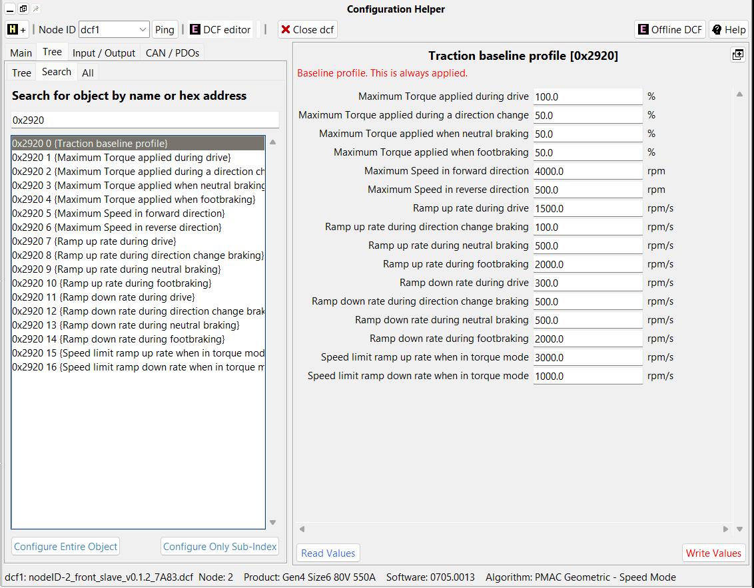

Now, let me tell you how to calculate and set the new Vehicle speed RPM value, if you have the new gear ratio. For this we do need to do some mathematical calculations. As we know vehicle speed is equals to the ratio of motor rpm to gear ratio and multiply by constant.

**maximum vehicle speed = (Motor rpm / gear ratio) * constant.**

To equate two equations with new and old values in the Zeekrom, in order to obtain the new RPM value to be set. Let me explain with the example; Suppose you have the old rpm sets in zeekrom is 4000, old gear ratio is 10.214 and new gear ratio is 15.2. so the new rpm would be;

(old rpm / old gear ratio)* constant value = (new rpm / new gear ratio) * constant value

4000/10.214 = New rpm / 15.2 ( Same constant value is using for both equations)

New rpm = (4000 *15.2) / 10.214 = 5952.61 rpm = Approx 6000 rpm.

Now, write the new rpm value in to the 0x2920, 5 address of object dictionary. So you have set the new rpm value for known gear ratio in Sevcon motor controller. Find the maximum speed in reverse direction also.

Note: Gear ratio will be same for the both forward and reverse direction.

**2. How to calculate the Motor to vehicle speed ratio fraction values**

The Sevcon motor-controller has a built-in feature that can convert motor RPM to kilometers per hour (Kmph) or miles per hour (Mph) based on specific vehicle speed ratio values. By default, Sevcon displays speed data in 10mph units, which means to get accurate Kph data (represented by 0x2721), you need to multiply the motor RPM to 10mph data by 16.09344.

To enable this conversion, you simply input the vehicle speed ratio fraction value (numerator and denominator) in index 0x2915 sub-index 1 and 2.

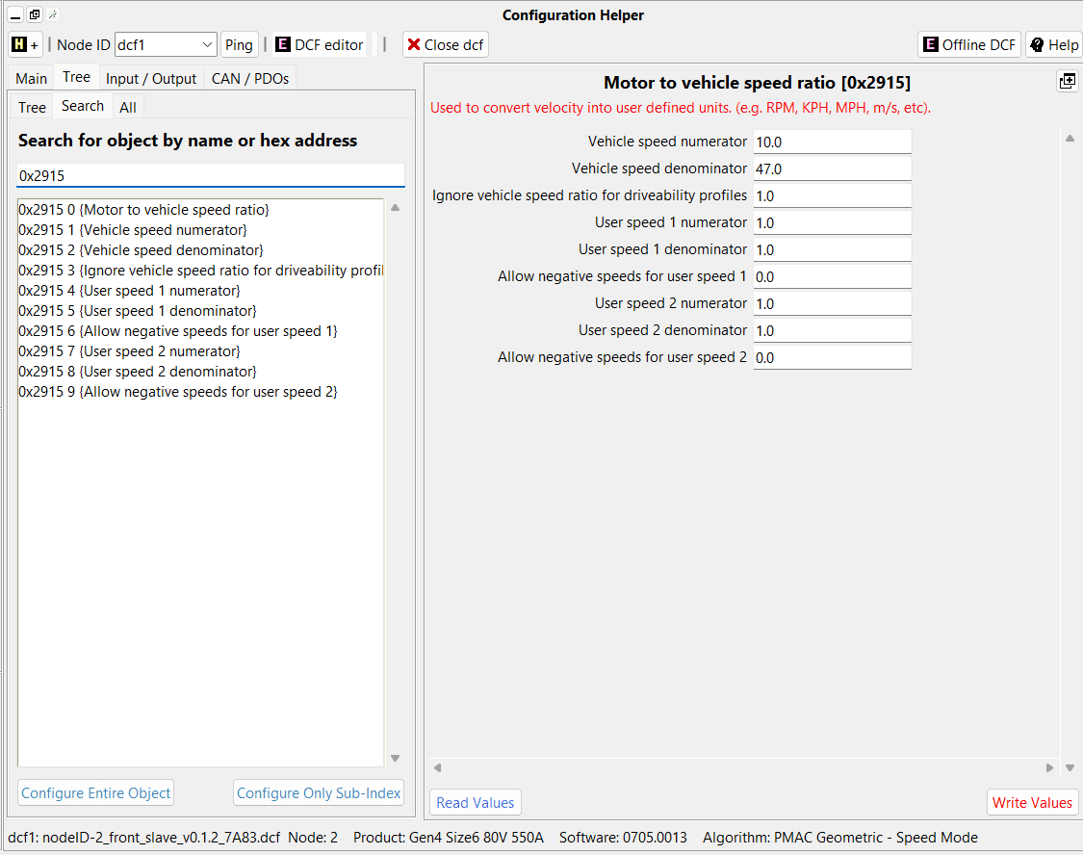

Here's how the Sevcon motor-controller internally calculates Kph:

((3 x pi) / 50) * (1/16.09344) * Motor RPM x (wheel diameter in meters / gear ratio)

Therefore, the numerator and denominator for the Sevcon vehicle speed ratio (to ensure accurate Kph at 0x2721) can be calculated as:

**((3 x pi) / 50) x (16.09344) x (wheel diameter in meters / gear ratio)**

Let meexplain with the example; suppose the wheel diameter is 0.676 meters, gear ratio is 10.214.

= ((3 x pi) / 50) x (16.09344) x (0.676 / 10.214)

= 0.20077093924

NOTE: The above calculation is as per manufacturer's tire dimension. This will overstate the speed. True speed will always be less because of load

Now we need to change the decimal float values to fraction values by using the below python script.

import math

targetValue = 0.20077093924

minDelta = 1

previousDelta = 1;

for i in range(1, 65535): #65535 because numerator and denominator are Uint16

for j in range(1, 65535):

delta = abs(targetValue - i/j)

if j > 1:

if delta > previousDelta:

break

previousDelta = delta

if delta < minDelta:

minDelta = delta

targetNumerator = i

targetDenominator = j

print(minDelta)

print(targetNumerator)

print(targetDenominator)

After the running script the numerator would be 3073 and denominator would be 15306. Now we have set the value in Index 0x2915, sub-index 1 and 2.

Therefore, with the motor to vehicle speed ratio fraction set in 0x2915, the odometer will provide precise readings for both distance traveled and kilometers per hour (Kmph).